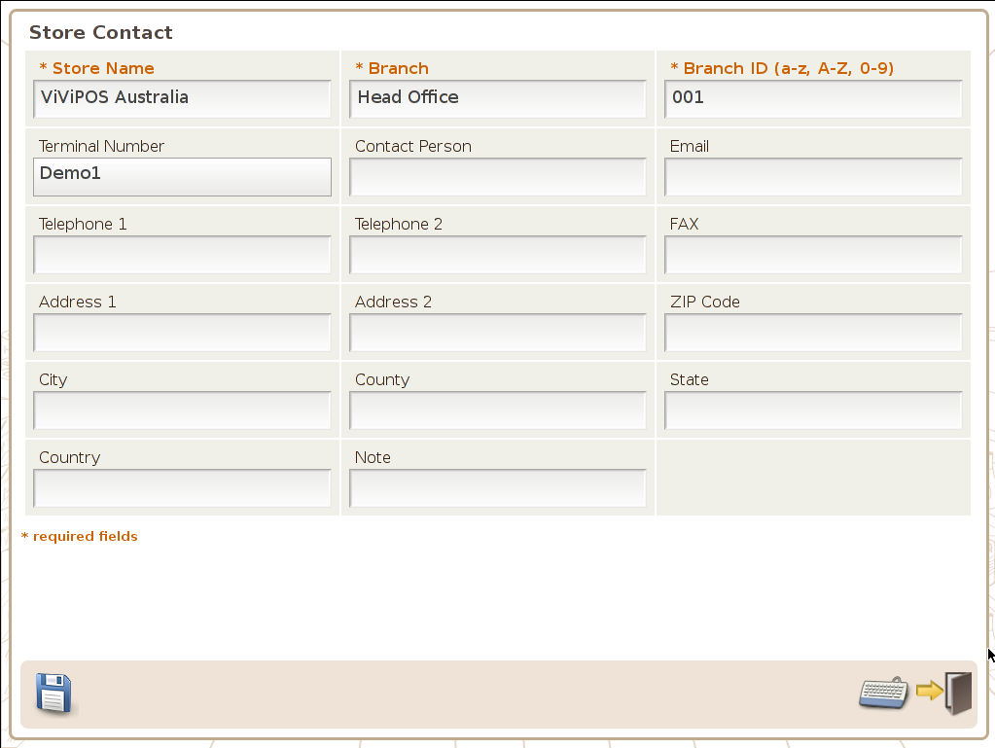 | Store Name  Branch  ID  Contact Person  Email  Telephone
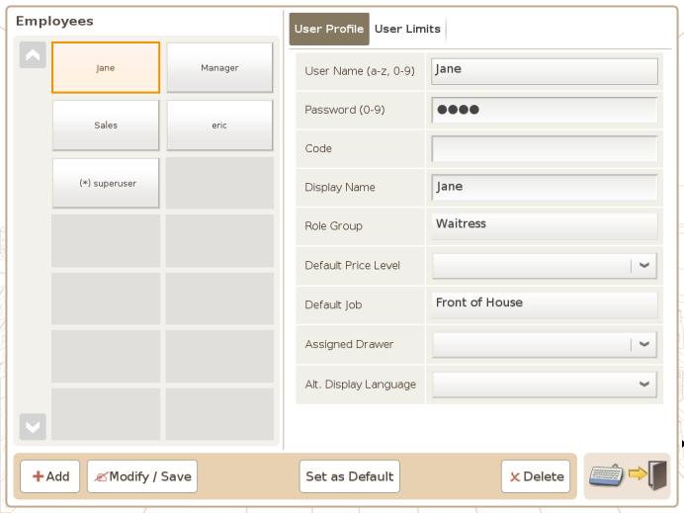 | Up to 6 Names/Jobs to be supplied  Default Role Groups:  - Administrator (super-user)  - Manager  - Clerk
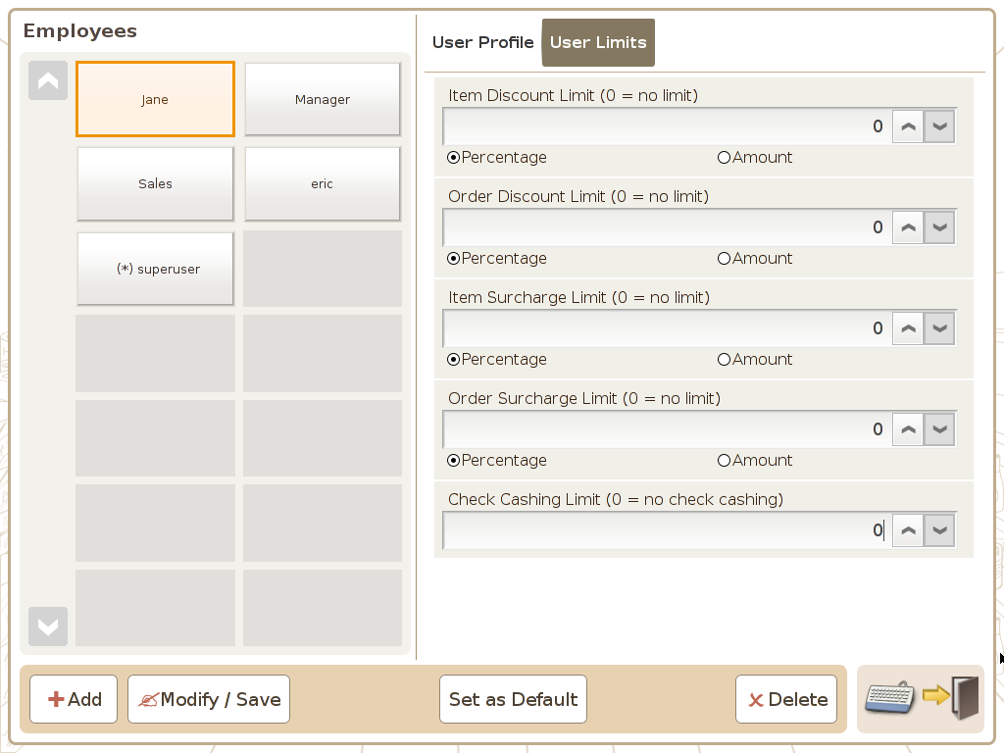 | ViViPOS will not setup User Limits
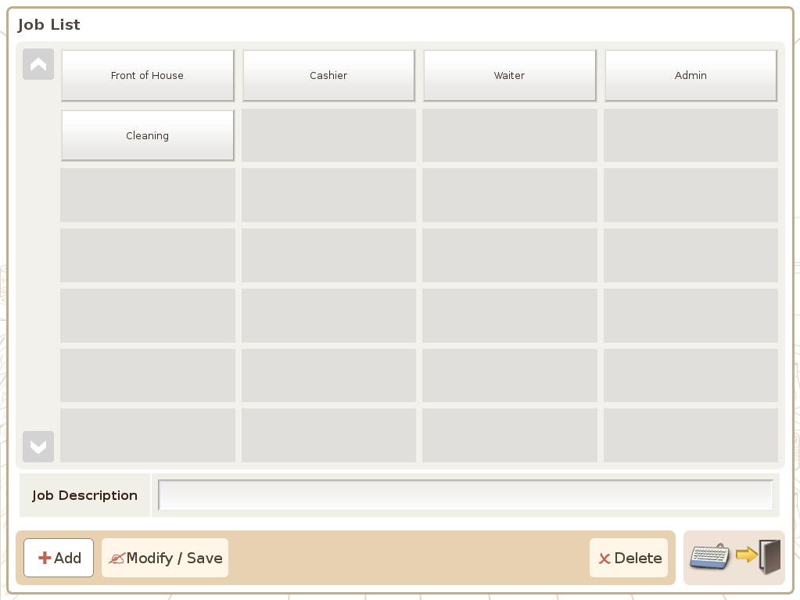 | Up to 6 Jobs to be supplied (associated with Employees supplied earlier)
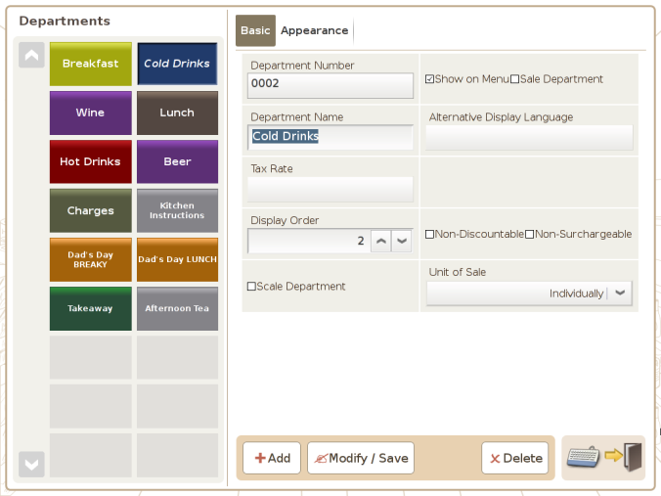 | Supply menu or Product list (ViViPOS decides initial structure & layout)
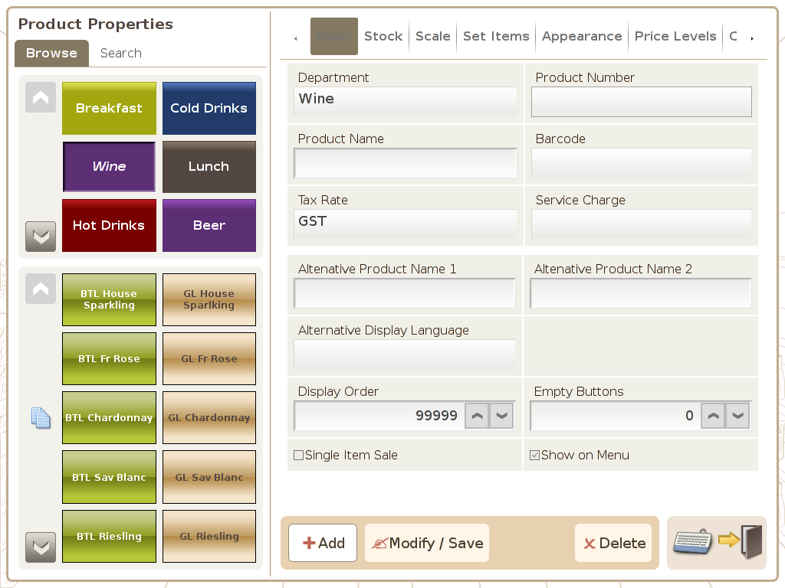 | Supply menu or Product list (ViViPOS decides initial structure & layout)
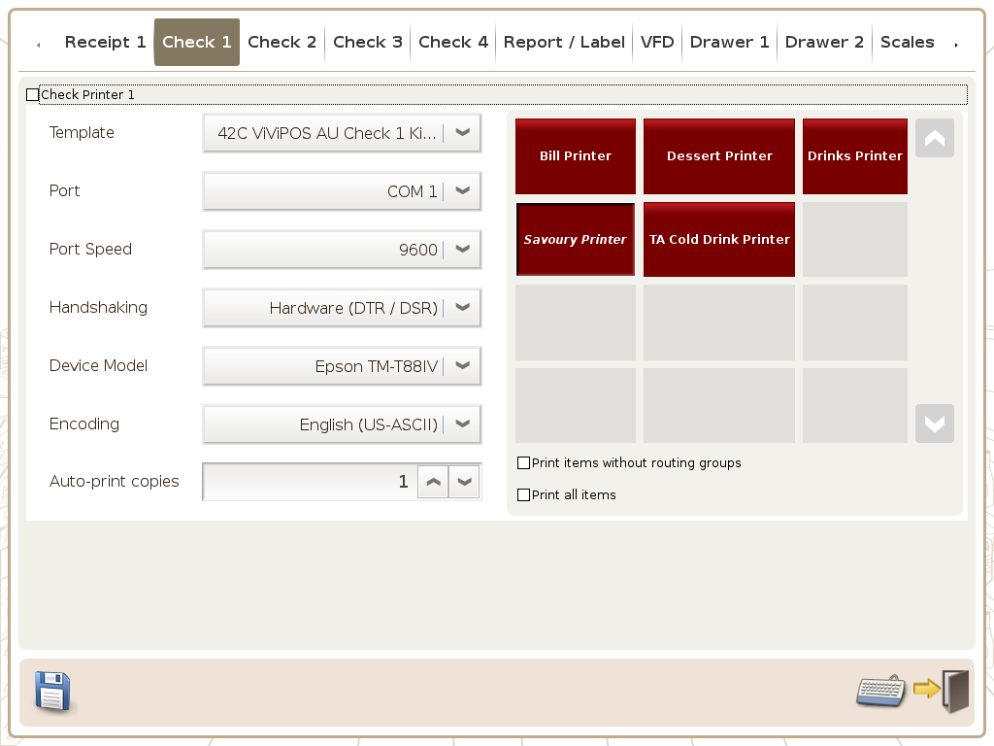 | Number of printers (different checks) not actual printers. Up to 4 to be supplied
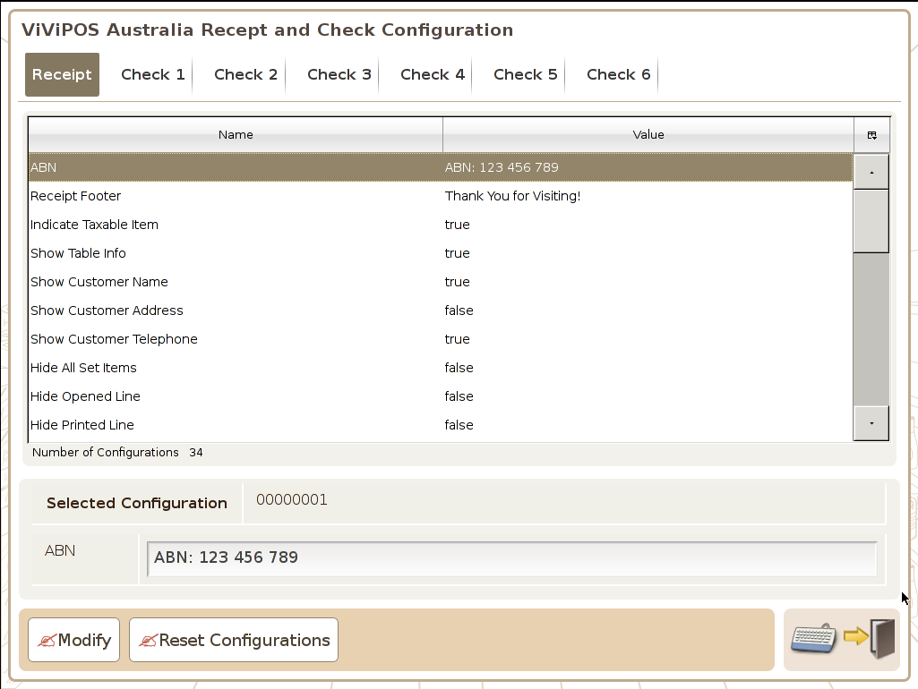 | ABN  Receipt footer Message
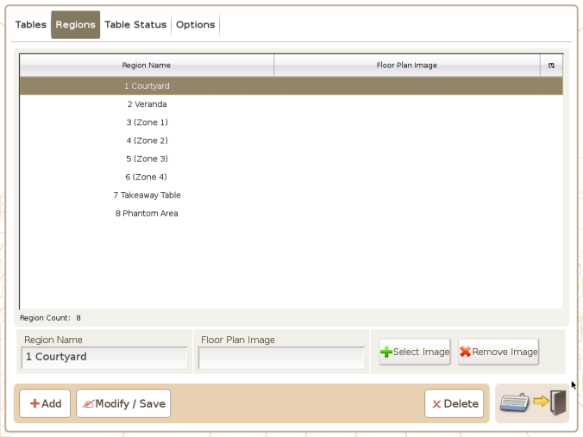 | Table Regions
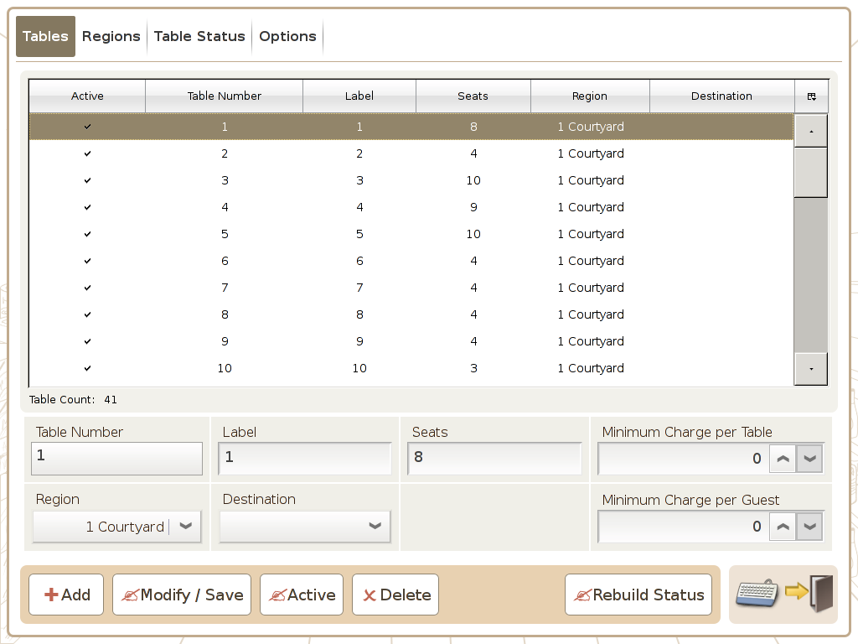 | Table numbers/capacity/Region (up to 20 to be supplied)
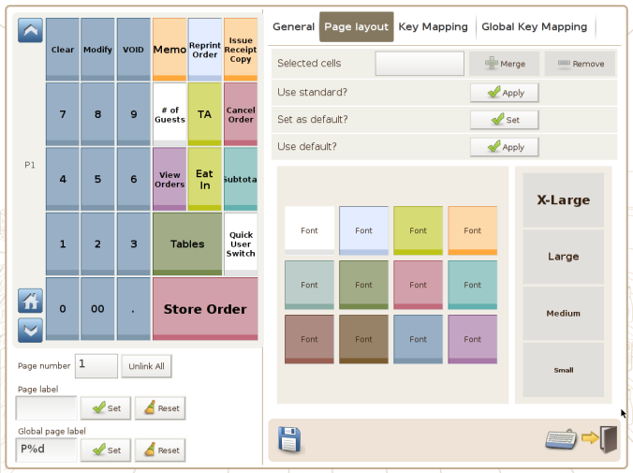 | Supply menu or Product list (ViViPOS decides initial structure & layout)
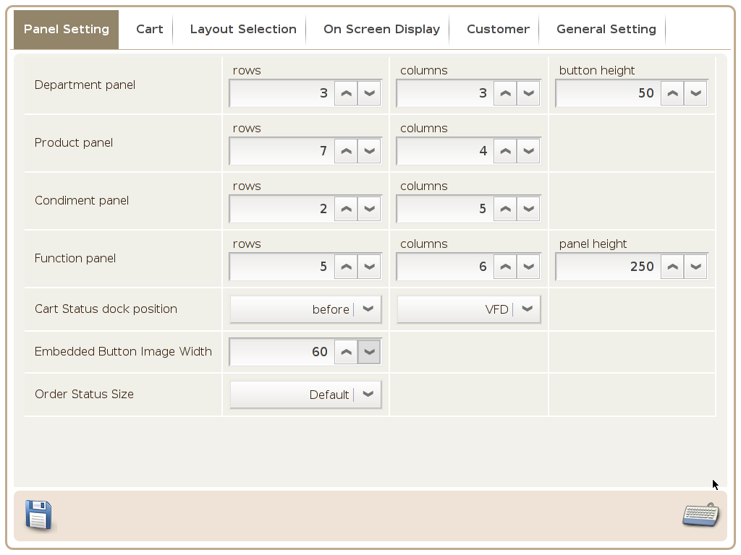 | Supply menu or Product list (ViViPOS decides initial structure & layout)

